**Loan Catch All at BMC**

* Customer ID: 2000013995
* Contract LD: LD1629520305
* Client Name: PHAT CHINDA
* Loan Size: USD1,500
* Term Loan: 36M
* Interest Rate: 9%
* Disburse Date: 20161021
* Maturity Date: 20191025

Loan Outstanding Report:

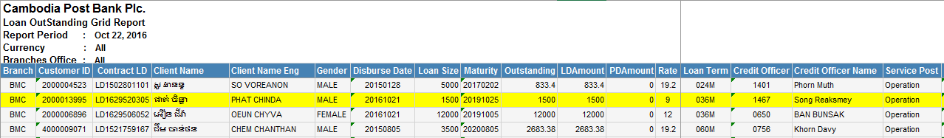

GL Report:

CRB-Catch All

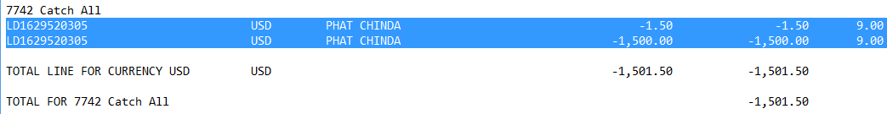

CRC-Catch All

